

SPONSOR
QUICK START
GUIDE

The purpose of this RAPIDS Sponsor’s Quick Start Guide is to enable the new user to Access the system and perform the basic actions of registering, canceling and completing apprentices. For a more extensive and in depth discussion of the capabilities of the RAPIDS system please consult the complete edition of the RAPIDS manual.

Table of Contents

1.1 Accessing the RAPIDS System……………………………………………………..… page 3
1.2 Log-in………………………………………………………………………………………. page 4
1.3 Register Apprentice…………………………………………………………………..…. page 6
1.4 Complete Apprentice………………………………………………………………….… page 8
1.5 Cancel Apprentice………………………………………………………………….……. page 12

Note: Before beginning the training session, please set up your computer and be ready for the training.

1.1 Accessing RAPIDS Website

To access RAPIDS:

- At your browser address box (Internet Explorer is the preferred browser), enter the following URL in the IE Address Box:
https://www.rapids.doleta.gov
- The “Security Warning Message” screen appears.

- Click Agree.

- The RAPIDS login screen appears

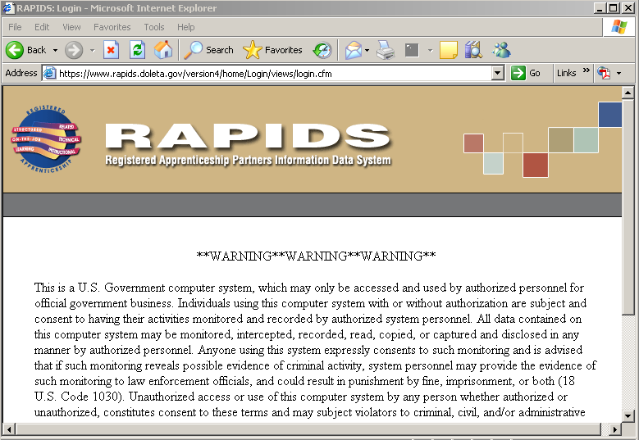


1.2 Log In
These next few steps will show a user how to log in to RAPIDS and prepare to work on the various functions necessary to register apprentices and programs. To log in, follow the steps below:

- Enter the User ID that was assigned to you in the USER ID box.
- Enter the password that was assigned to you in the Password box.
- Click on the Login button or press the Enter key on your keyboard.
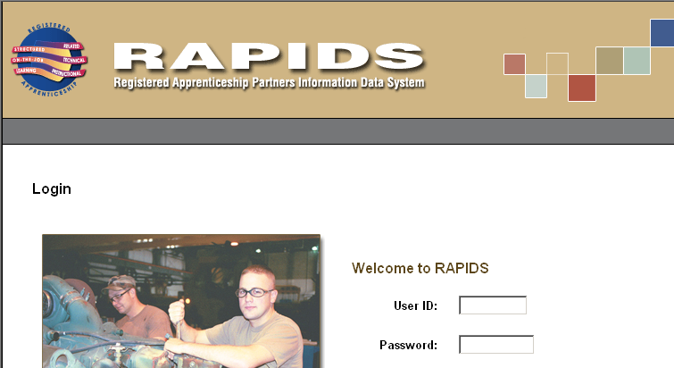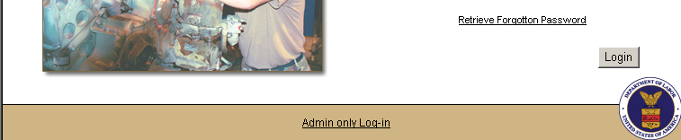

Result: The Home page will display, as shown below:

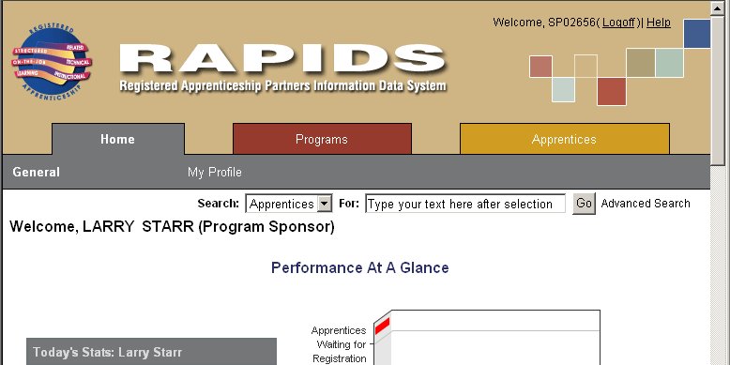

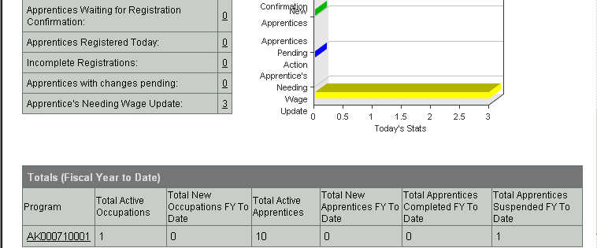

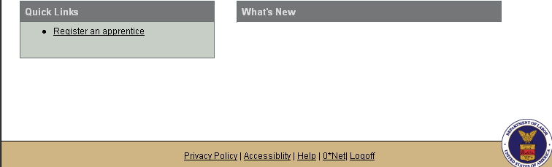

1.3 Register Apprentice
From the Apprentice Main Page, click the Register tab.

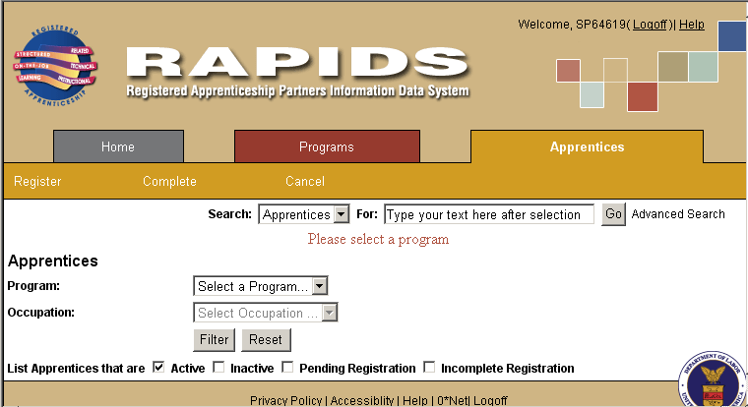

This function allows you to create a new apprentice record. The data elements of an apprentice record are organized into five sub-tabs:
- Program & Occupation
- Name & Address Info
- Ethnicity, Race, Education
- RTI Info
- Confirm & Sign

To create a new apprentice record, follow the steps for each section below:
Note: Entry is required in all fields with an asterisk (*) beside the field name.

On the Program & Occupation Section
- Select a Program from the drop-down list.
- The system will display the occupation drop-down list. Select the occupation on the drop-down list.
- Click Next to proceed to Name & Address section.
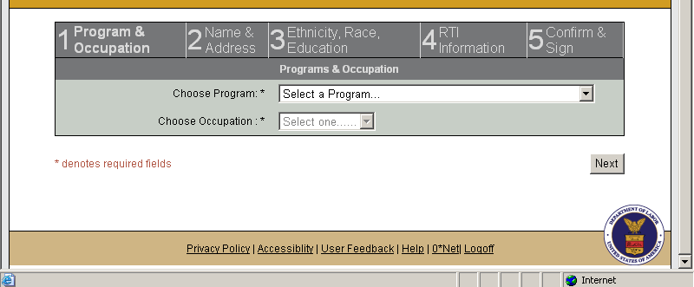

Confirm & Sign Section
Continue entering registration data. In order to complete the process of registering an apprentice, you must confirm by attaching your electronic signature as shown on the next page. When you have completed the last page of data entry, you will be taken to the bottom of a page showing the information you entered, with the Confirm & Sign function at the bottom.
If you wish to change or correct any of the data you entered before confirming, click the Update button that corresponds to the page you wish to correct.
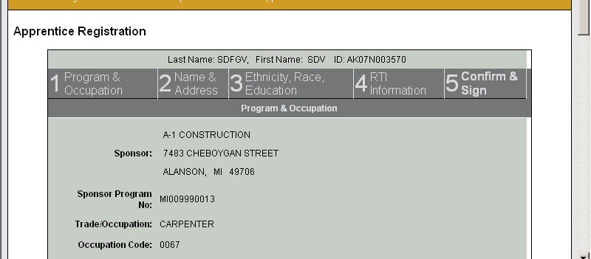
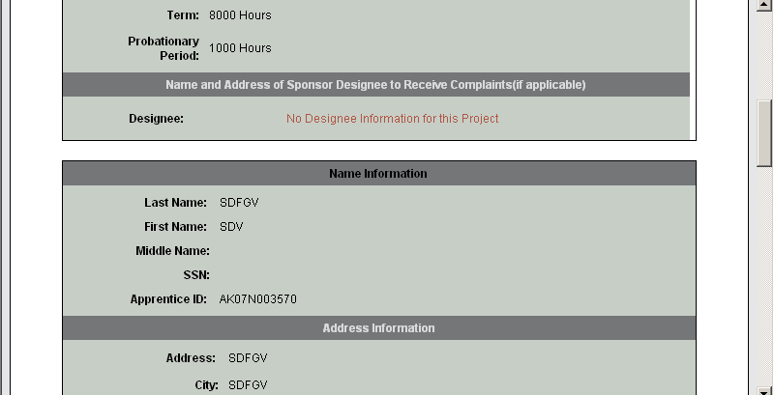
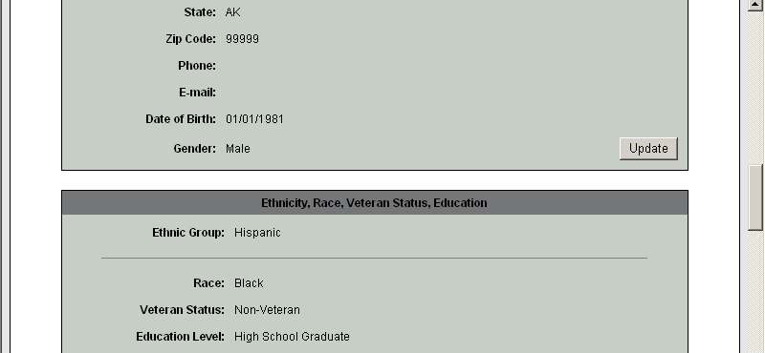
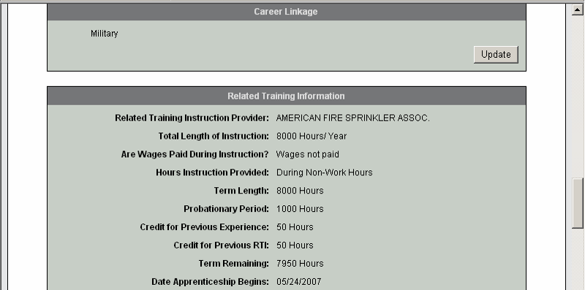
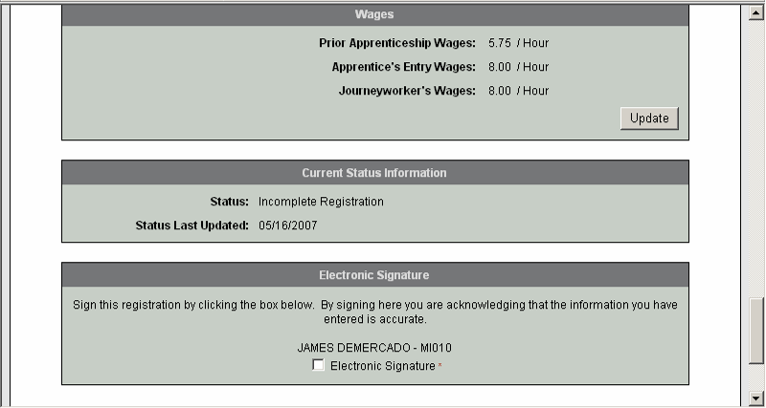
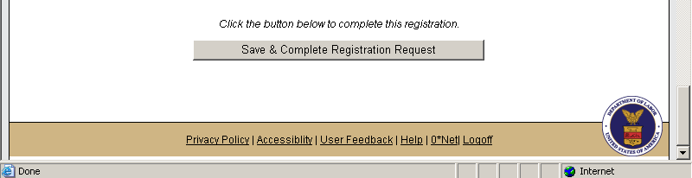

To complete the registration, check the Electronic Signature box, and then click the Save & Complete Registration Request button. You will be returned to the Apprentice List View page, with the new record added to the list.

Note: After the Apprentice Registration Request is complete, the ATR will review it. If it was approved, then the process is completed. If the ATR declines the Apprentice Registration, the Sponsor can review it on the List View and will have the option to re-submit it.

1.4 Complete Apprentice
This function allows you to modify one or more apprentice records to reflect the completion of his or her apprenticeship. To complete an apprenticeship, click the Apprentice tab, then click the Complete sub tab. Select a program and occupation (optional). You will see the table of all active apprentices for which you are responsible, with a preview icon for each one, and a "Select" column on the left containing check-boxes with which to select apprentices for completion.

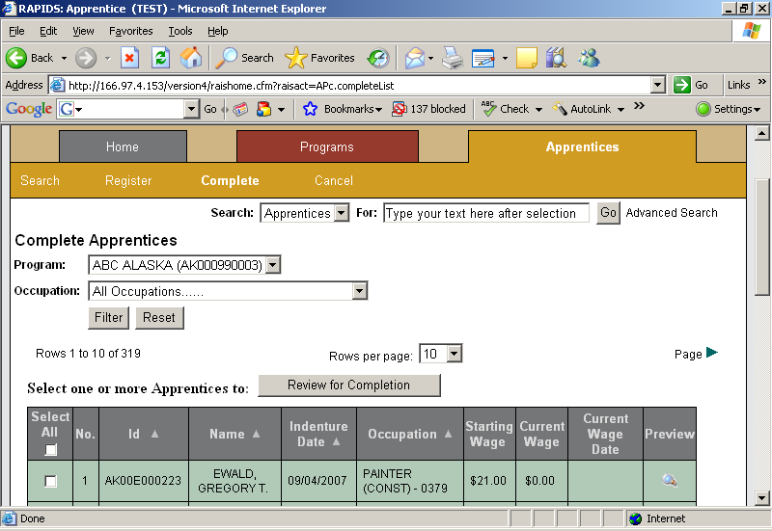

To complete apprentices:
- Check the box for each apprentice you wish to complete. To complete all of the apprentices in your list, click the Select All box at the top of the column.
- Click the Review for Completion button above the table. You will be shown a table of all of the apprentices you have selected for completion.

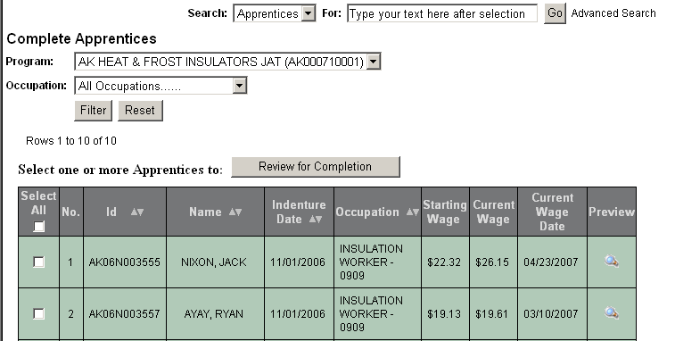

Result: System displays the Complete Apprentice form

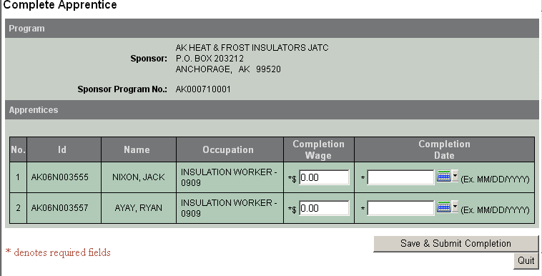

Note: Entry is required in all fields with an asterisk (*) beside the field name.
- Enter the Completion Wage for each apprentice.
- Enter the Completion Date for each apprentice, in MM/DD/YYYY format; or click the calendar icon to select a date.
- Click Save & Submit Completion to save your request, or Quit to cancel the operation.

To verify the Completion Record:
- Click the Apprentice tab.
- Select the Program name fro the drop down list.
- Select the occupation from the drop down list (option)
- Select the “Inactive” option.

Result: The system will display the completed record(s) on the list

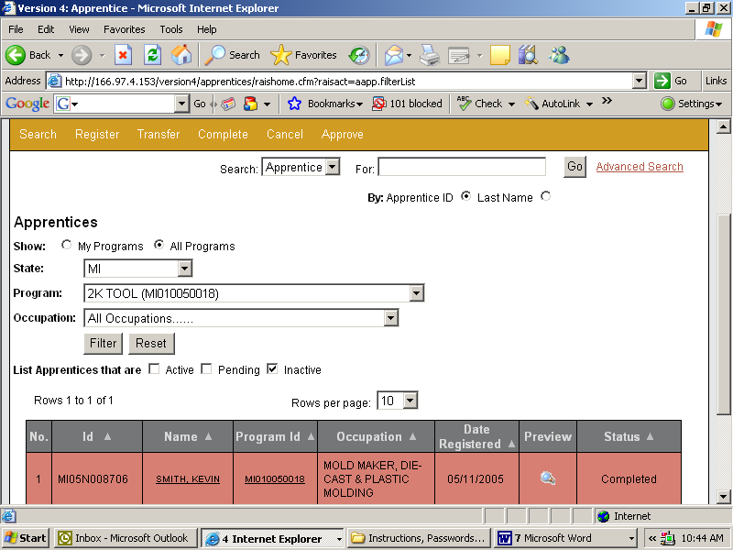

1.5 Cancel Apprentice
This function allows you to cancel an apprentice's participation in an apprenticeship program. To cancel an apprentice, click the Apprentice tab, then click the Cancel sub tab. Select a program and occupation (optional). You will see the list of all active apprentices for which you are responsible, and a "Select" column on the left containing check-boxes with which to select apprentices for cancellation.

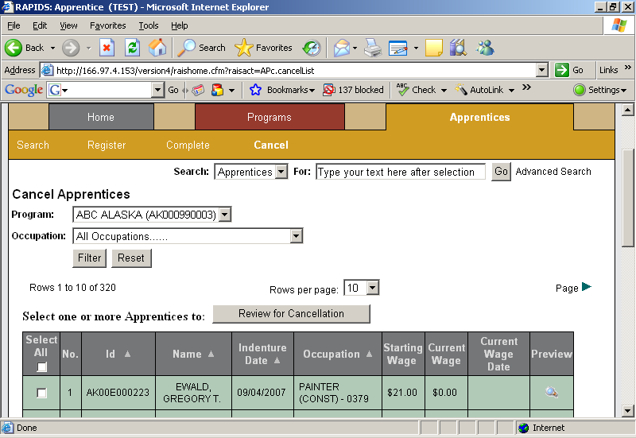

To cancel apprentices:
- Check the box for each apprentice you wish to cancel. To cancel all of the apprentices in your list, click the Select All box at the top of the column.
- Click the Review for Cancellation button above the list. You will be shown a list of all of the apprentices you have selected for cancellation, showing the apprentice's information, and the information about his/her program and occupation.

Result: System displays the Cancel Apprentice form
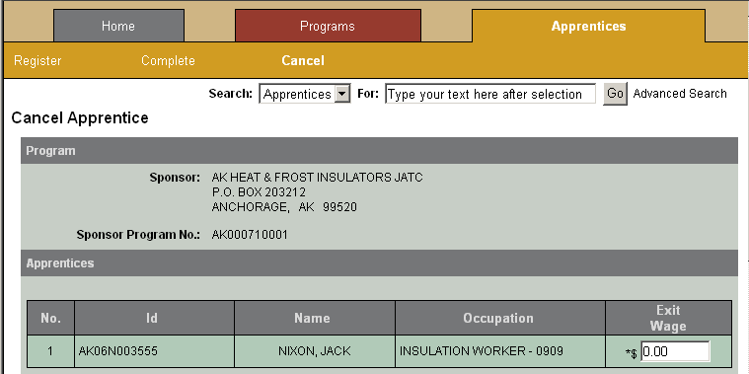
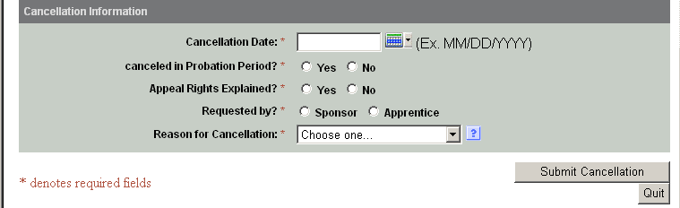

Note: Entry is required in all fields with an asterisk (*) beside the field name.
- Enter the Cancellation Date for each apprentice, in MM/DD/YYYY format; or click the calendar icon to select a date.
- Check whether the apprentice is being cancelled within his/her Probation Period.
- Check whether the apprentice's Appeal Rights were explained.
- Select the Reason for Cancellation from the drop-down list.
- Click Submit Cancellation to complete the request for cancellation, or Quit to cancel the operation.

